1. **Asritha**

**Coding Challenge 3_RDBMS_CrimeManagement**

1. Creating Database and Tables :

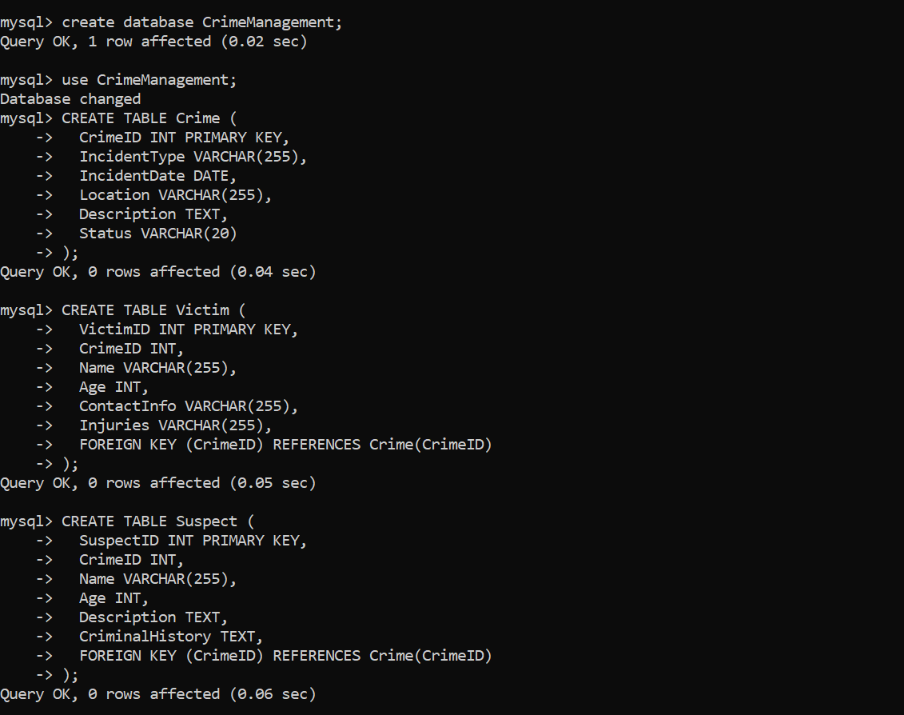

1. Inserting values into tables

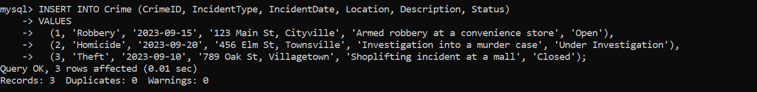

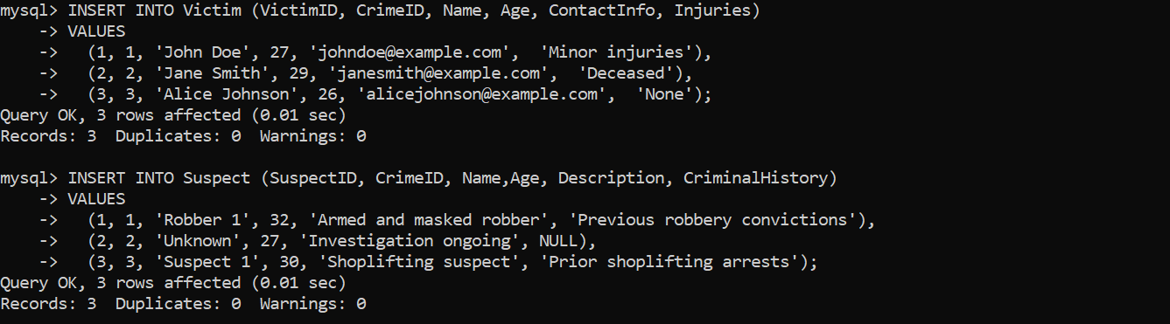

**Solve the below queries:**

1. Select all open incidents.

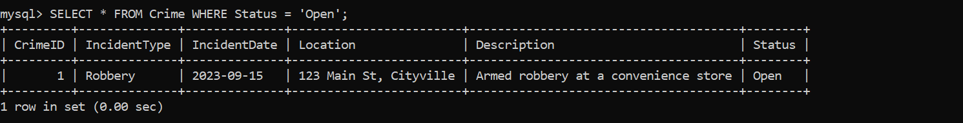

1. Find the total number of incidents

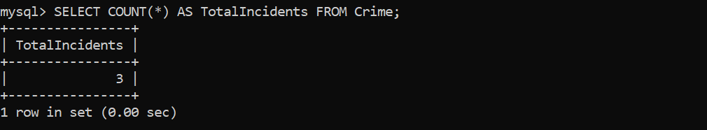

1. List all unique incident types.

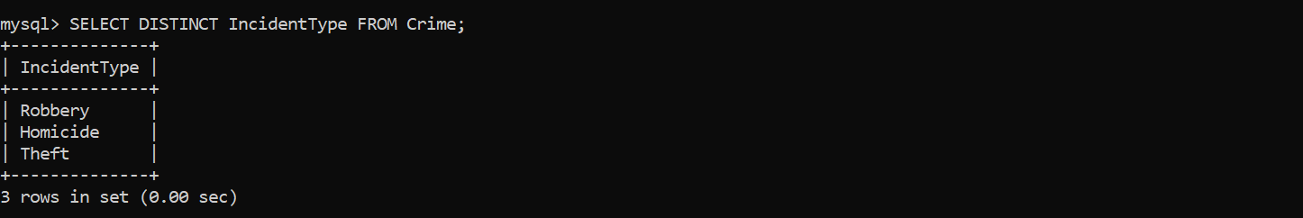

1. Retrieve incidents that occurred between '2023-09-01' and '2023-09-10'.

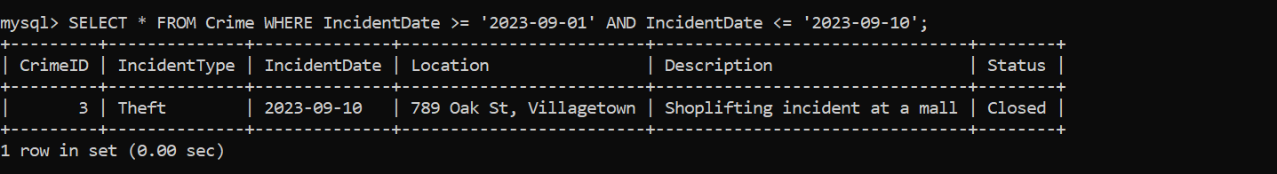

1. List persons involved in incidents in descending order of age.

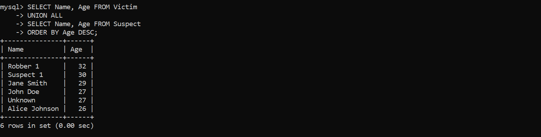

1. Find the average age of persons involved in incidents.

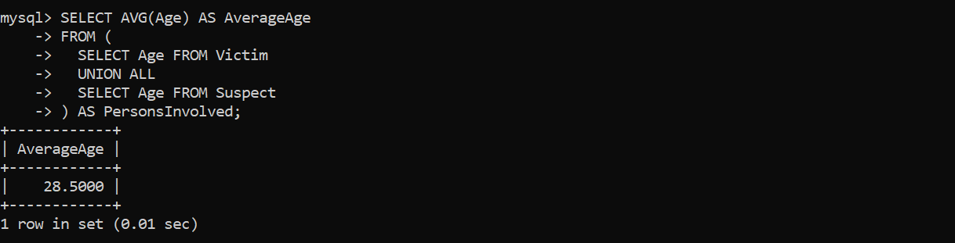

1. List incident types and their counts, only for open cases.

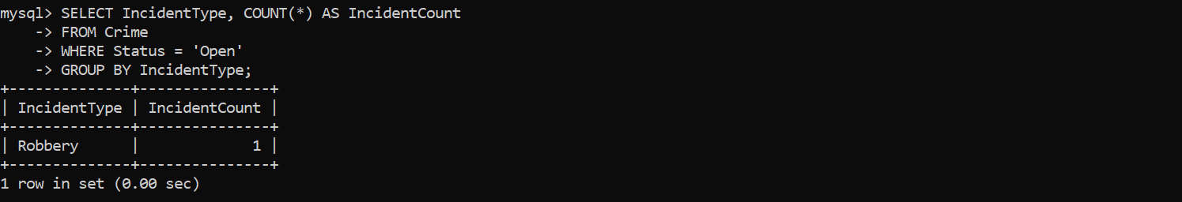

1. Find persons with names containing 'Doe'.

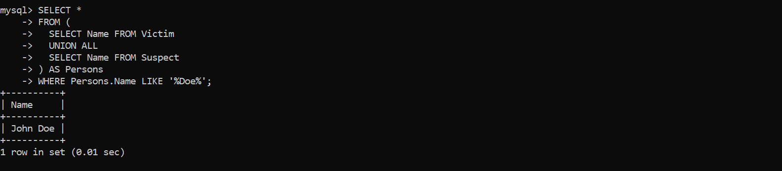

1. Retrieve the names of persons involved in open cases and closed cases.

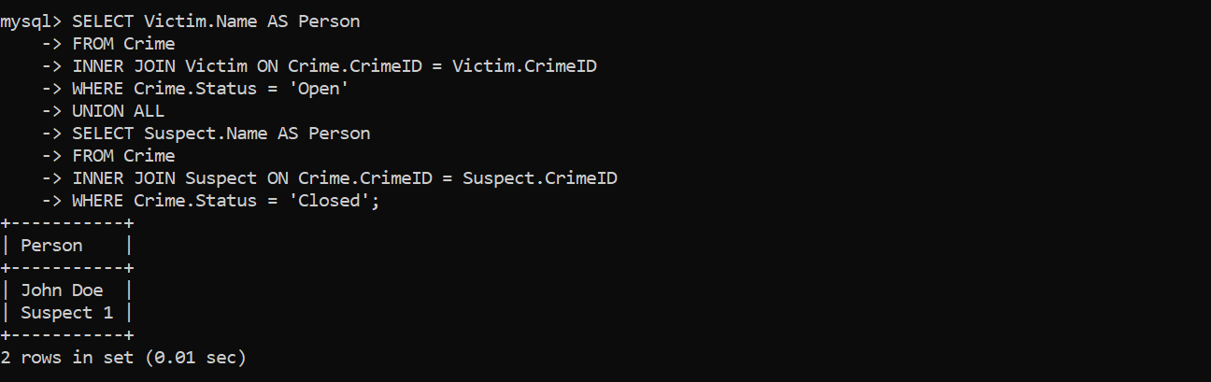

1. List incident types where there are persons aged 30 or 35 involved.

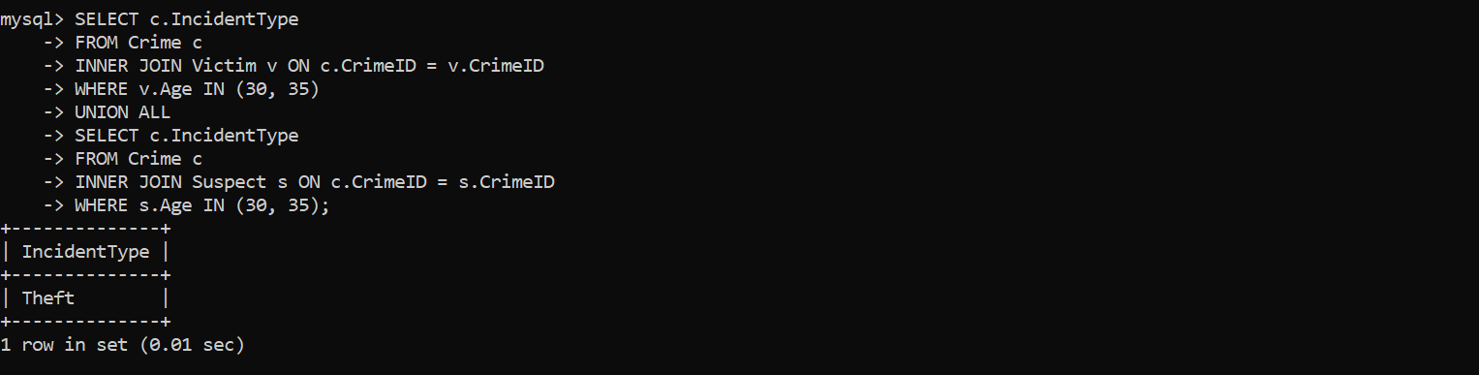

1. Find persons involved in incidents of the same type as 'Robbery'.

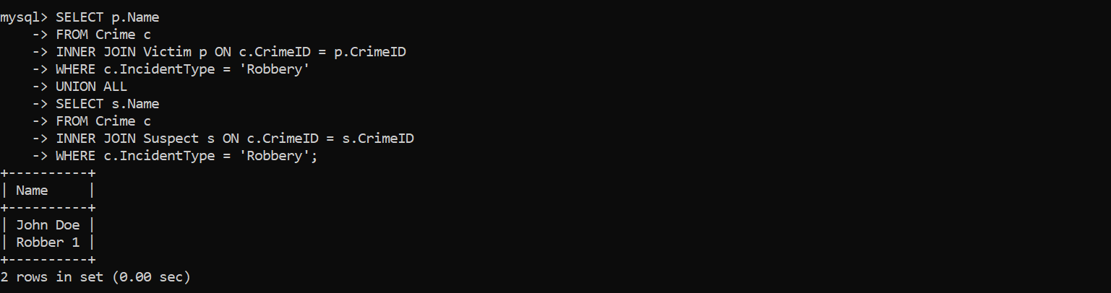

1. List incident types with more than one open case.

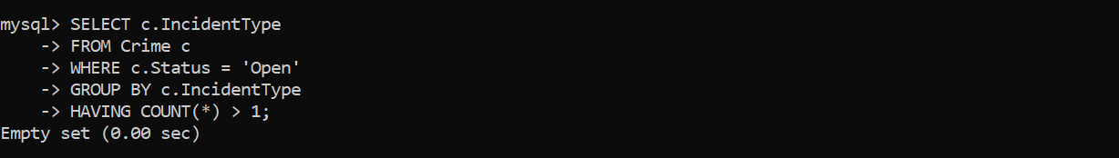

1. List all incidents with suspects whose names also appear as victims in other incidents.

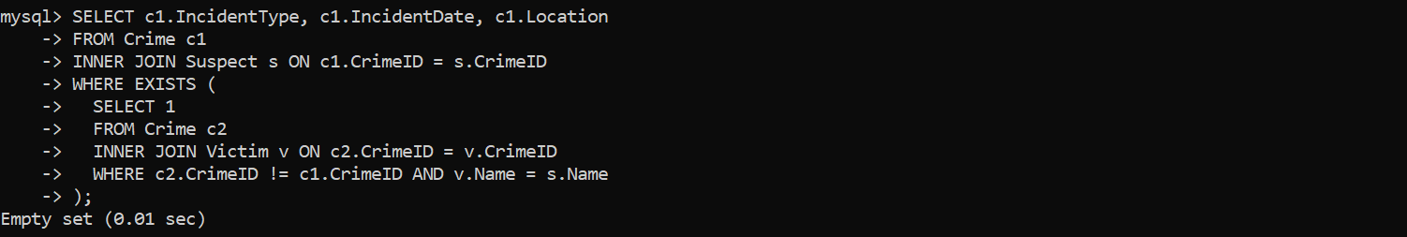

1. Retrieve all incidents along with victim and suspect details.

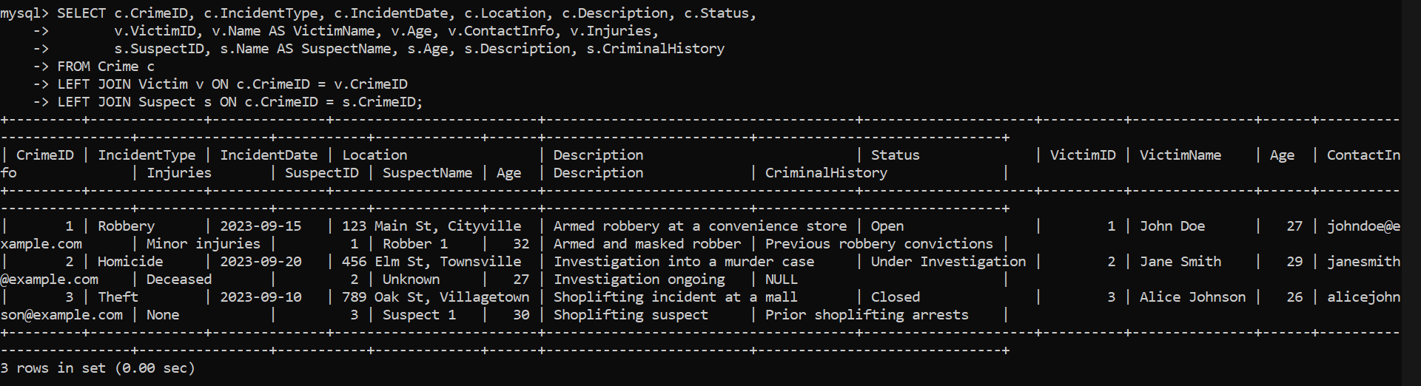

1. Find incidents where the suspect is older than any victim.

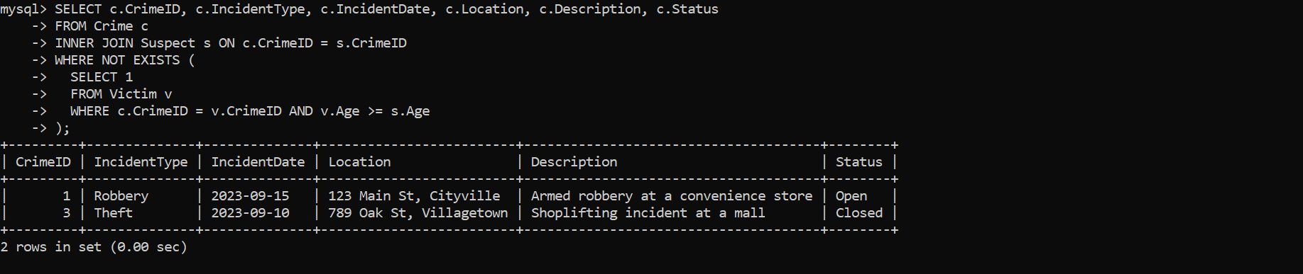

1. Find suspects involved in multiple incidents:

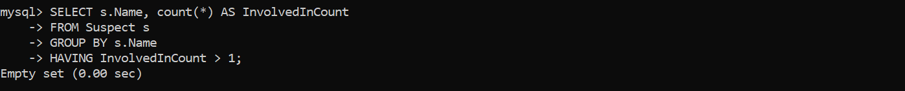

1. List incidents with no suspects involved.



1. List all cases where at least one incident is of type 'Homicide' and all other incidents are of type 'Robbery'.

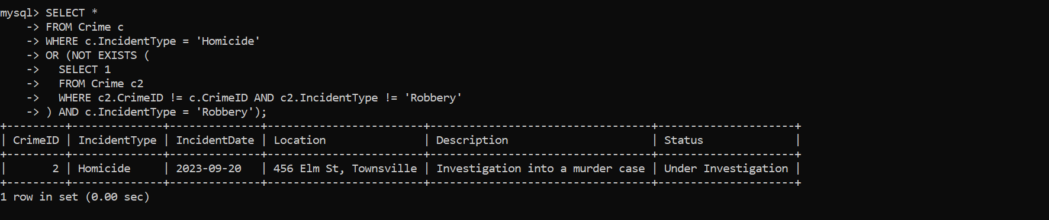

19.Retrieve a list of all incidents and the associated suspects, showing suspects for each incident, or 'No Suspect' if there are none.

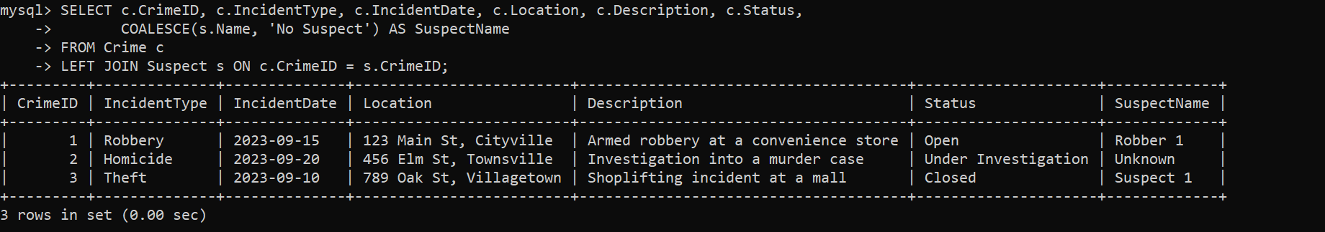

20.List all suspects who have been involved in incidents with incident types 'Robbery' or 'Assault

